|  |
| --- |
| aut university |
| Agenda |
| Automation Project |
|  |
|  |
|  |

## Group Members

1. Nguyen Thai Huy
2. Nguyen Hieu Thuan
3. Nguyen Xuan Phuong

## Supervisor

Tran Minh Tuan

|  |
| --- |
|  |

Contents

1. GENERAL INFORMATION 3

2. ATTENDENCE 3

3. MEETING CONTENTS - Feedback for Project Proposal 4

4. ACTION AFTER THE MEETING 4

# GENERAL INFORMATION

* Time: Fri Jan 11, 2017 8:30am – 9:30am (ICT)
* Location: ITEC, Library
* Purpose: [NIFTIT] Discuss about working time

# ATTENDENCE

|  |  |  |
| --- | --- | --- |
| Group Members | Email | Phone |
| 1. Nguyen Thai Huy  2. Nguyen Hieu Thuan  3. Nguyen Xuan Phuong | [thaihuyaprotrainaptech@gmail.com](mailto:thaihuyaprotrainaptech@gmail.com)  [1159046@itec.hcmus.edu.vn](mailto:1159046@itec.hcmus.edu.vn)  [0959039@itec.hcmus.edu.vn](mailto:0959039@itec.hcmus.edu.vn) | 0908711689  0969134604  0969134604 |

|  |
| --- |
| Present at Meeting:  Team Members: Nguyen Thai Huy  Nguyen Hieu Thuan  Nguyen Xuan Phuong    Absent: N/A |
|  |

# 

# MEETING CONTENTS

**Frond-end:**

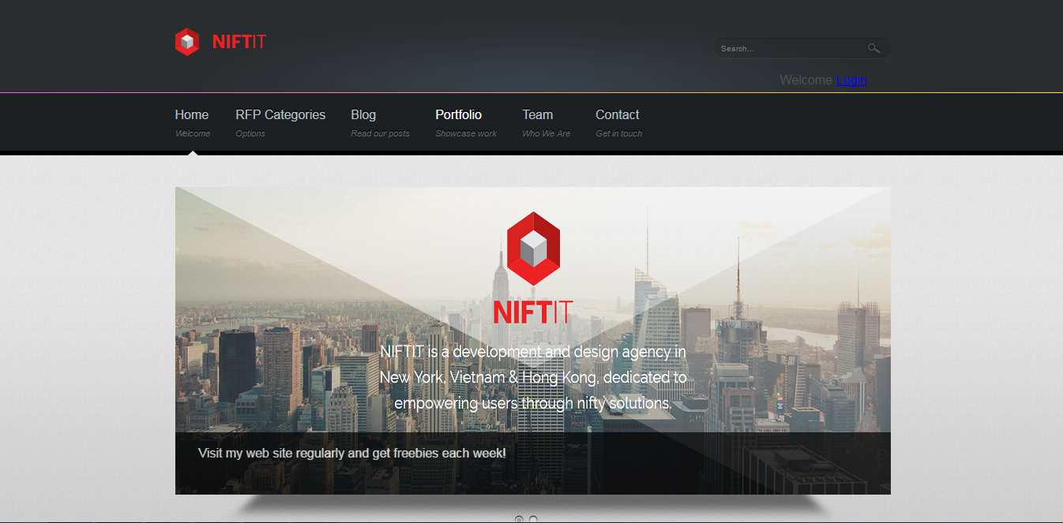



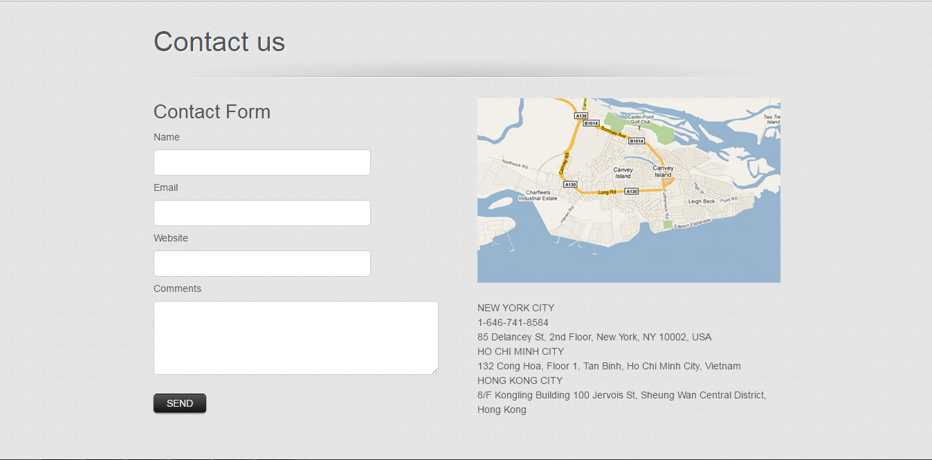

**Back-end:**

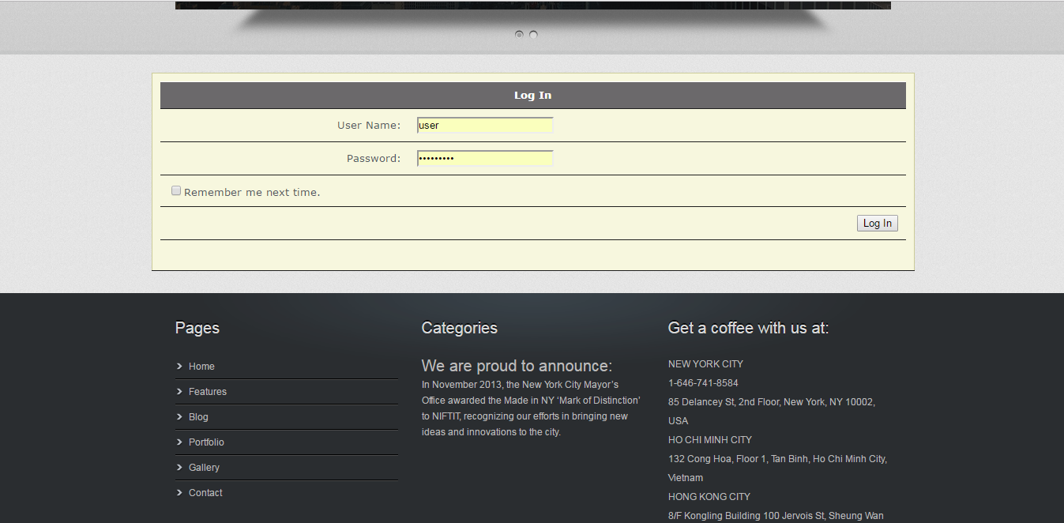

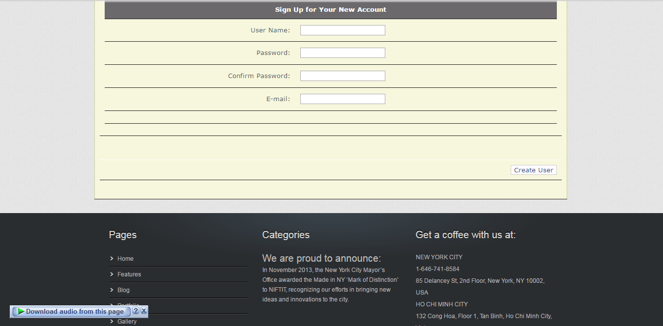

# ACTION AFTER THE MEETING

